Project Design Phase-II
Data Flow Diagram & User Stories
Date | 31 January 2025
Team ID | __________
Project Name | ShopEZ
Maximum Marks | 4 Marks

Data Flow Diagrams:
A Data Flow Diagram (DFD) shows how information moves through the ShopEZ system. It highlights the interaction between customers, admins, the application, and the database.
Level 0 DFD (Context Diagram):
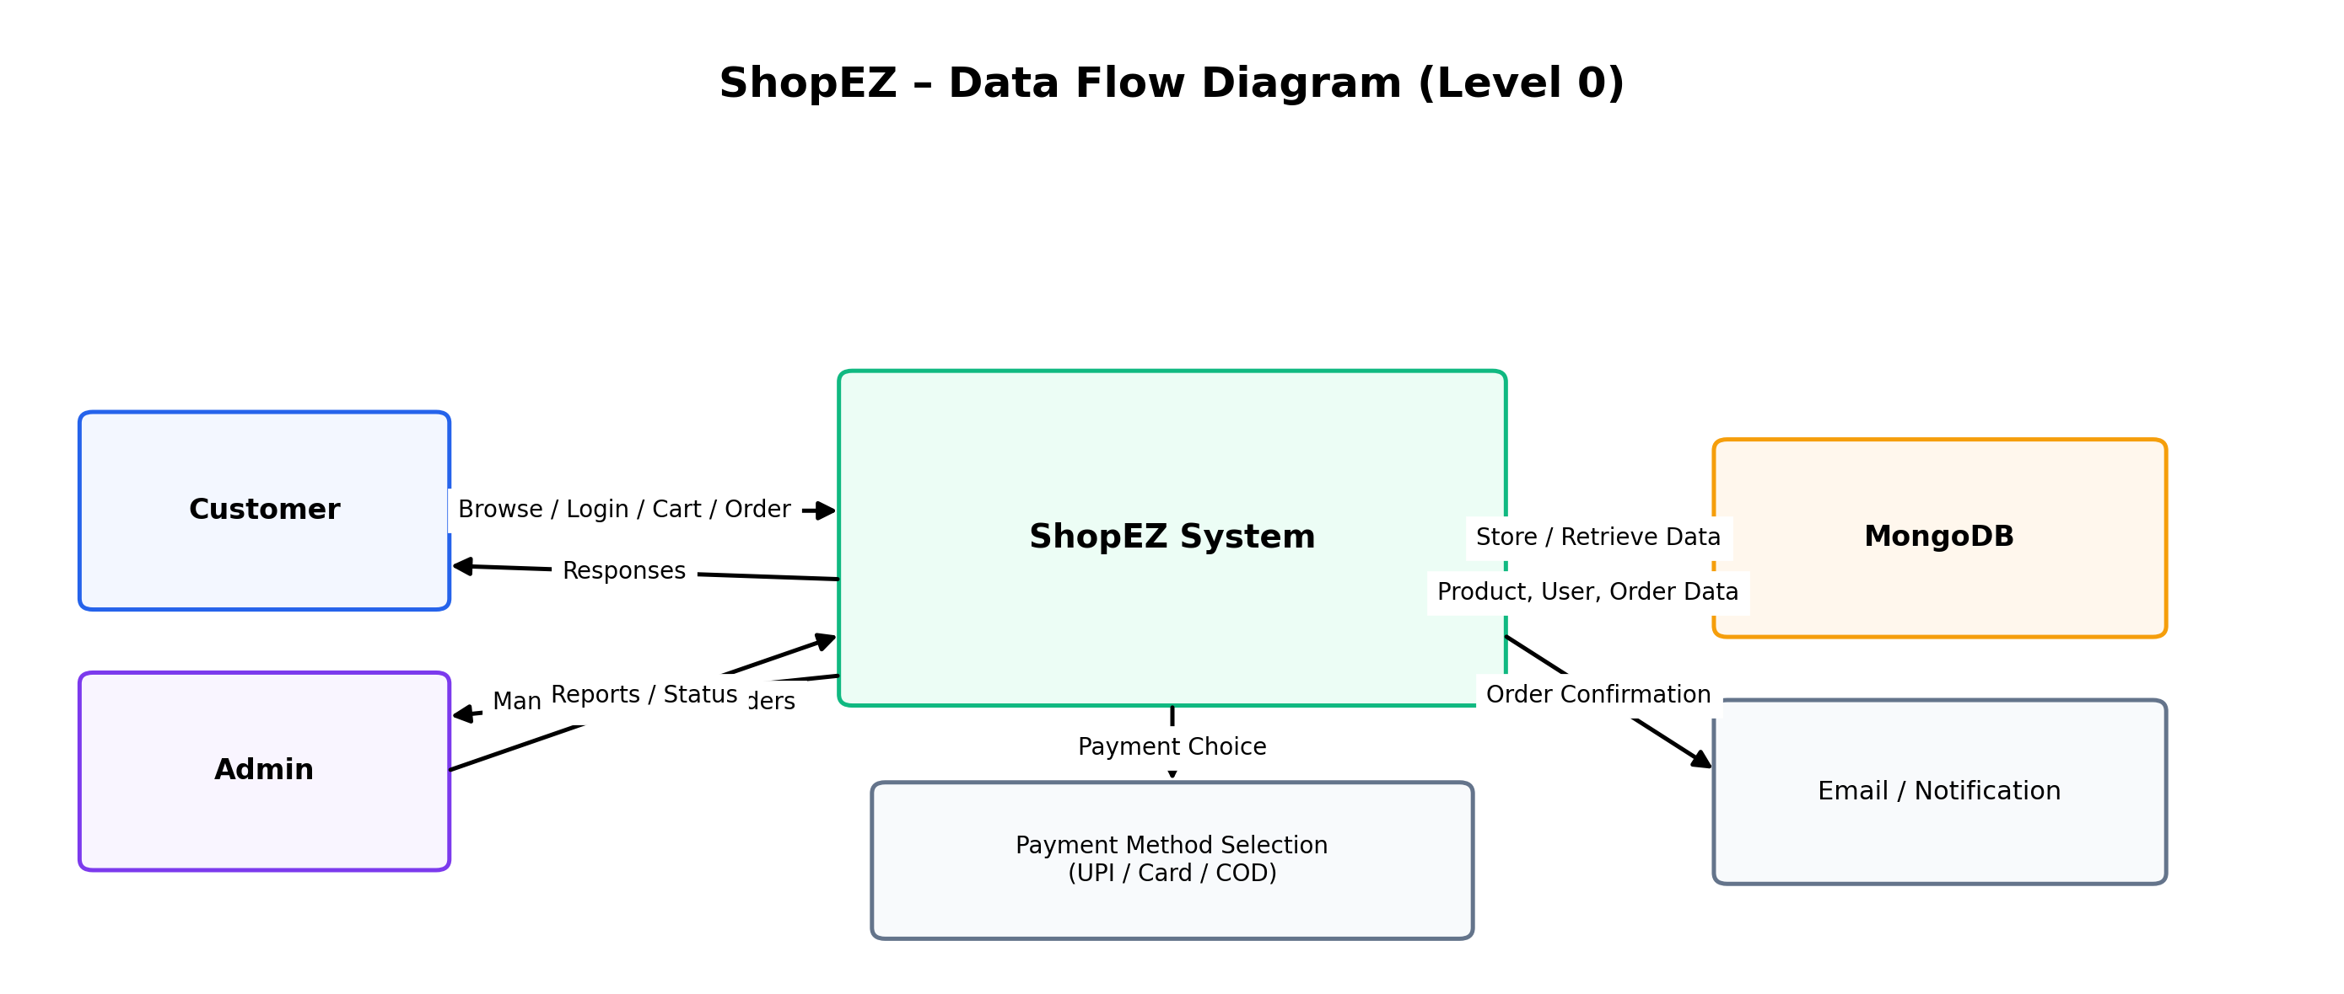
Level 1 DFD (Detailed View):
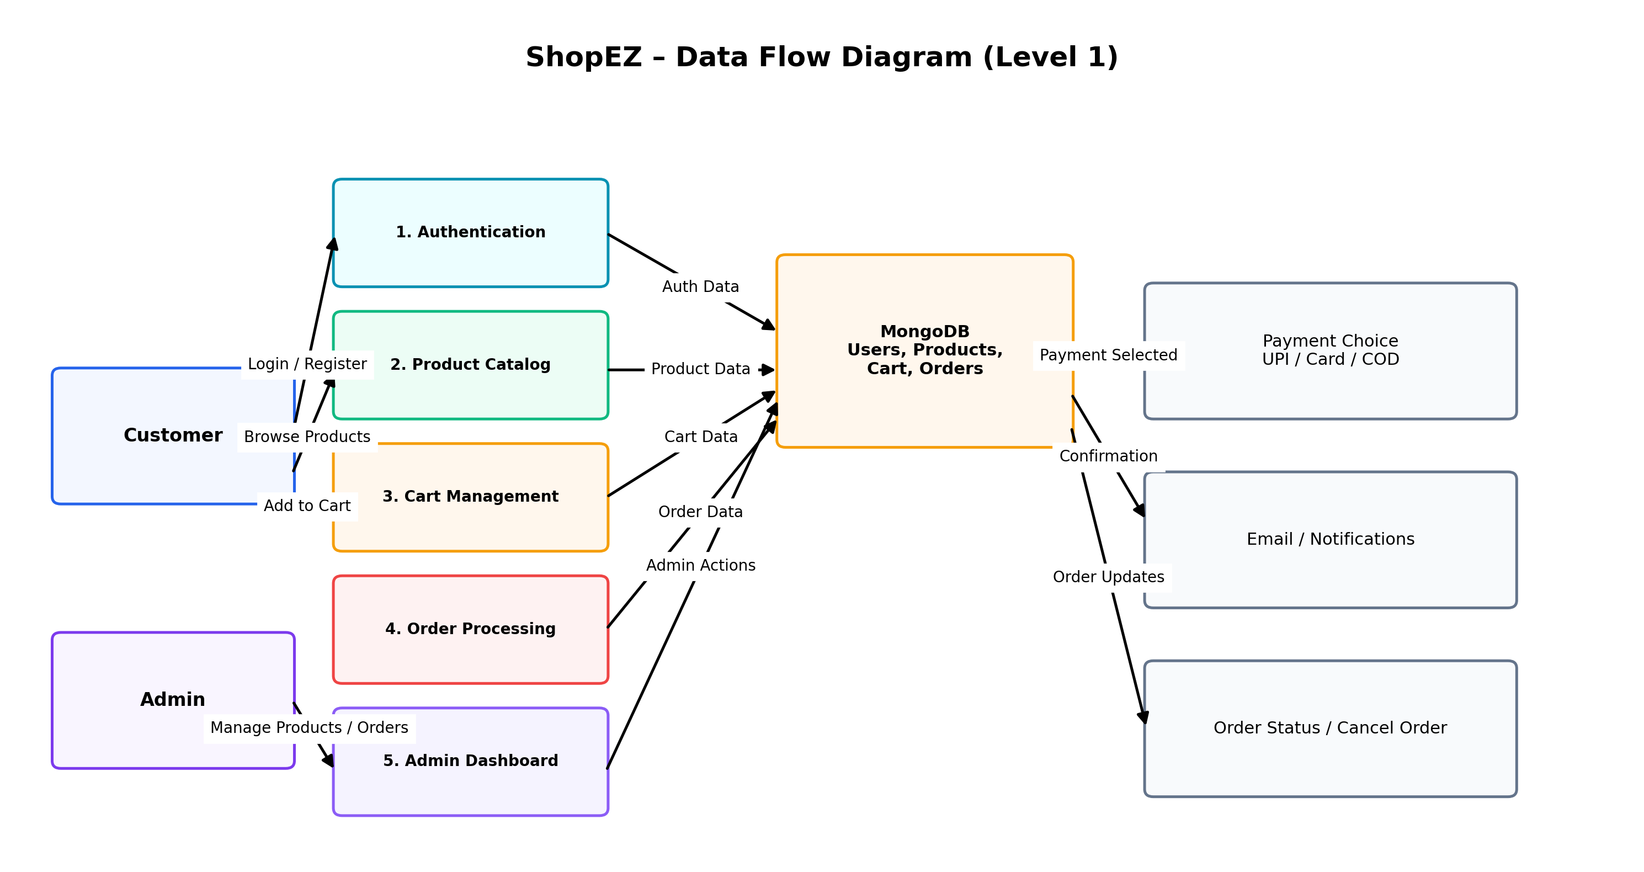

User Stories
Use the table below to list the user stories for the ShopEZ product.
User Type | Functional Requirement (Epic) | User Story Number | User Story / Task | Acceptance criteria | Priority | Release
Customer  (Mobile/Web) | Registration | USN-1 | As a user, I can register by entering my name, email, password, and confirming the password. | I can create an account successfully. | High | Sprint-1
Customer  (Mobile/Web) | Login | USN-2 | As a user, I can log in using my email and password. | I can access my account/dashboard. | High | Sprint-1
Customer  (Mobile/Web) | Product Browsing | USN-3 | As a user, I can view all products and product details. | I can browse products easily. | High | Sprint-2
Customer  (Mobile/Web) | Cart Management | USN-4 | As a user, I can add and remove products from cart. | Cart updates correctly. | High | Sprint-2
Customer  (Mobile/Web) | Checkout | USN-5 | As a user, I can place an order and choose UPI/Card/COD. | Order is placed successfully. | High | Sprint-3
Customer  (Mobile/Web) | Order Management | USN-6 | As a user, I can view and cancel my orders. | Order history and cancel feature work correctly. | Medium | Sprint-3
Administrator | Admin Dashboard | USN-7 | As an admin, I can manage products and orders. | I can add/update/delete products and manage orders. | High | Sprint-4

Note: The user stories are aligned with the ShopEZ MERN e-commerce application features.
Project scope includes authentication, product catalog, cart, checkout, order cancellation, and admin management.

